Full-time Employment Opportunity -
Sturgis Police Department

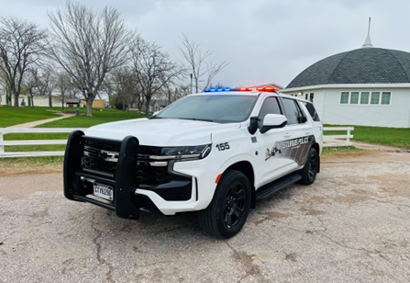
Full Time Patrol Officer

- Competitive base wage
- $26.96 per hour (non-certified)
- $27.36 to $29.00 per hour (per experience/qualifications)
- Preference for acceptable candidates with prior LE experience

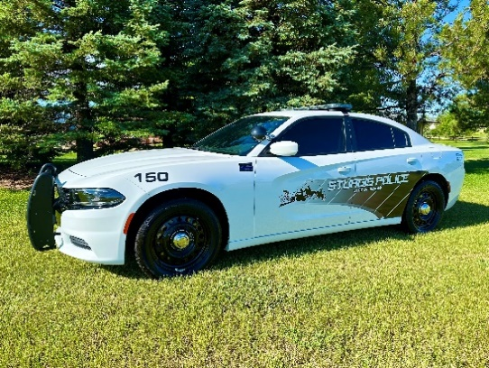
  - 12-hour work shifts – NO residency (City) requirement

- Every other weekend off
    - Work 5 shifts first week and only 2 shifts the second week
    - Fixed schedule – know when you’ll work for the rest of the year
  - Actual shift schedule TBD

- Participate in the South Dakota Retirement System, receive a pension when retire

- Additional annual retirement match up to $1,000 into the Supplemental Retirement Plan

$800 annual uniform allowance

- Opportunities for promotion and growth with department (i.e., bicycle or motorcycle patrol, SRT, SRO)

- Budget for staff to attend external training opportunities

- Additional benefits with (optional) membership to the Teamster Local 120

- Relaxed facial hair and tattoo policy

The Patrol Officer is responsible for performing general law enforcement functions related to law and order and is responsible for serving the legal processes of the courts.

Apply now! All applicants must submit a City employment application, supplemental law enforcement application, and resume. First review of applicants after August 29th.
To apply or for an ADA accommodation, please contact Asst. Chief Brian Paulsen
605- 347-5070, or email paulsen@sturgispolice.com

